**API Specification:**

1. Create Customer

Type: POST

Url: <http://localhost:8080/api/createcustomer>

Data (JSON):

{

    "id": 1,

    "name": "john",

    "email": "john@example.com"

}

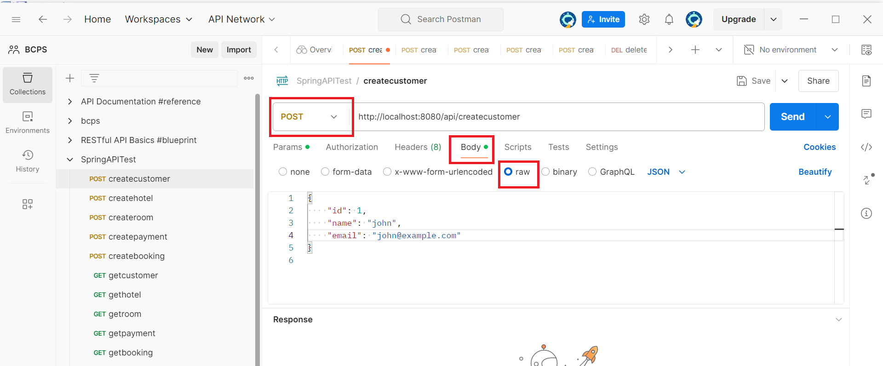

1. Create Hotel

Type: POST

Url: <http://localhost:8080/api/createhotel>

{

    "id": 1,

    "name": "seraton",

    "address": "banani"

}

1. Create Room

Type: POST

Url: <http://localhost:8080/api/createroom>

{

  "id": 1,

  "roomNumber": "101",

  "type": "Deluxe",

  "hotelId": 1

 }

1. Create Payment

Type: POST

Url: <http://localhost:8080/api/createpayment>

{

  "id": 1,

  "amount": 1500.00,

  "paymentDate": "2024-06-08",

  "paymentMethod": "Credit Card",

  "customerId": 1

}

1. Create Payment

Type: POST

Url: <http://localhost:8080/api/createbooking>

 {

  "id": 1,

  "startDate": "2024-06-08",

  "endDate": "2024-08-12",

  "customerId": 1,

  "roomId": 1,

  "paymentId": 1

}

1. Get Customer

Type: GET

Url: <http://localhost:8080/api/getcustomer/1>

1. Get Hotel

Type: GET

Url: <http://localhost:8080/api/gethotel/1>

1. Get Room

Type: GET

Url: <http://localhost:8080/api/getroom/1>

1. Get Payment

Type: GET

Url: <http://localhost:8080/api/getpayment/1>

1. Get Booking

Type: GET

Url: <http://localhost:8080/api/getbooking/1>

1. Update Customer

Type: PUT

Url: <http://localhost:8080/api/updatecustomer>

Data (JSON):

{

    "id": 1,

    "name": "john updated",

    "email": "john@example.com"

}

1. Update Hotel

Type: PUT

Url: <http://localhost:8080/api/updatehotel>

{

    "id": 1,

    "name": "seraton",

    "address": "gulshan 1"

}

1. Update Room

Type: PUT

Url: <http://localhost:8080/api/updateroom>

{

  "id": 1,

  "roomNumber": "101",

  "type": "Luxurious",

  "hotelId": 1

 }

1. Update Payment

Type: PUT

Url: <http://localhost:8080/api/updatepayment>

{

  "id": 1,

  "amount": 2000.00,

  "paymentDate": "2024-06-08",

  "paymentMethod": "Debit Card",

  "customerId": 1

}

1. Update Payment

Type: PUT

Url: <http://localhost:8080/api/updatebooking>

 {

  "id": 1,

  "startDate": "2024-06-08",

  "endDate": "2024-08-12",

  "customerId": 1,

  "roomId": 1,

  "paymentId": 1

}

1. Delete Customer

Type: DELETE

Url: <http://localhost:8080/api/deletecustomer/1>

1. Delete Hotel

Type: DELETE

Url: <http://localhost:8080/api/deletehotel/1>

1. Delete Room

Type: DELETE

Url: <http://localhost:8080/api/deleteroom/1>

1. Delete Payment

Type: DELETE

Url: <http://localhost:8080/api/deletepayment/1>

1. Delete Booking

Type: DELETE

Url: <http://localhost:8080/api/deletebooking/1>